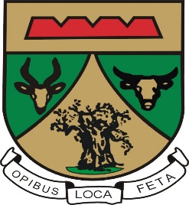

WARD REPORTING AND FUNCTIONS
2011-2016
Election of ward committees
60 Ward committees’ members were elected in 2011, from their respective wards. Each ward consist of 10 ward committee members, and all of them nominated from their community structures.
Ward committees hold 01 meeting every month and 01 mass meeting per quarter. All 06 wards were supposed to hold 72 ward committee meeting and 24 Ward Mass meetings annually.
Roles and responsibility of ward committee
- Each ward committee member was given a portfolio after training and their portfolios are:
- Housing and disaster
- Disability
- Infrastructure and LED
- Unemployment and Women
- Sports, Arts and Culture
- Safety and Security
- Education and Communication
- Roads and transport
- Health
- Water and Sanitation
Reporting of ward committee members
- Each ward committee member was supposed to report every month according to their portfolios that they were given after they were trained.
Challenges Experienced
Some ward committee were not complying.
- Some did not submit their reports
- Some were not attending their meetings regularly
- Others resigned due to their personal reason.
- Some members passed away.
Majors taken to address challenges
- Some ward committee members were relieved from their duties due to non-compliance.
- Developed attendance register to keep record of attendance.

