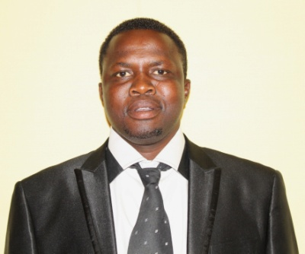 | 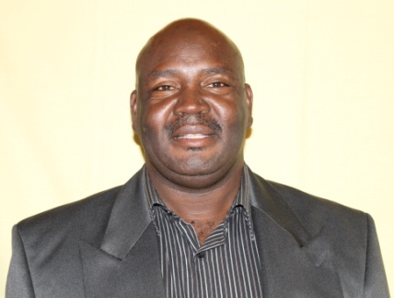 | 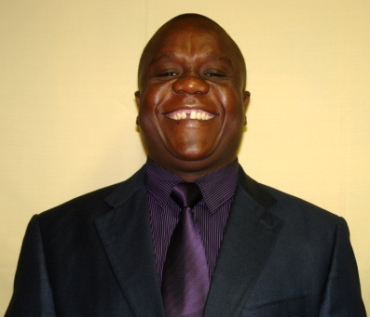
Councillor F Mafela (ANC)  Ward 1 | Councillor S Phiri (ANC)  Ward 2 | Councillor SFL Ndhlovu  (Chief whip – ANC – Ward 3)
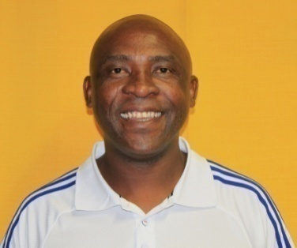 | 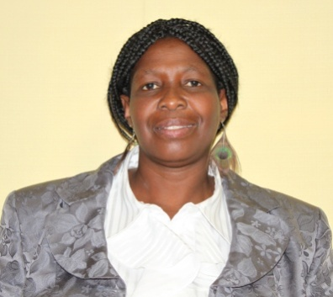 | 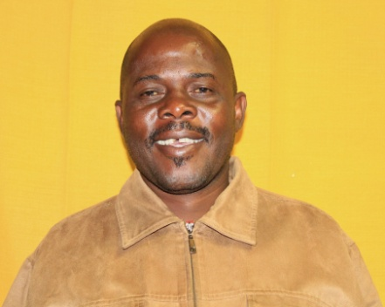
Councillor LB Ndou (ANC)  Ward 4 | Councillor GL Milanzi (ANC)  Ward 5 | Councillor JC Kaunda (ANC)  Ward 6
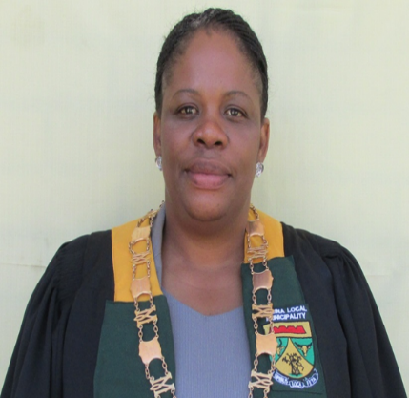 |  | 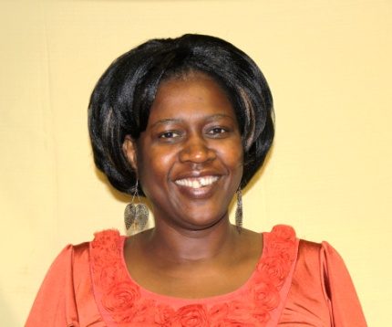
Councillor ME Ramoyada  (PR – ANC) | Councillor CM Phiri  (PR - ANC) | Councillor – ES Shirilele  (PR - ANC)
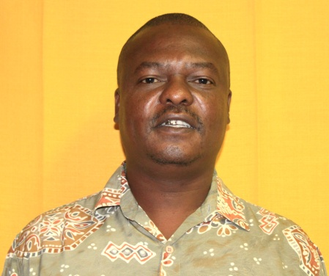 | 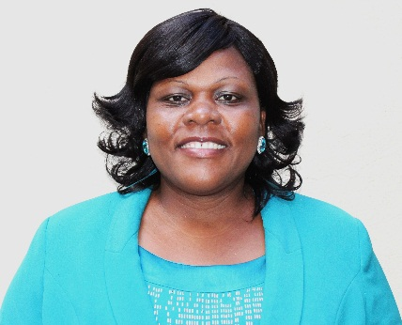 | 
Councillor P Tlou  (PR - COPE | Councillor G Mavhungu  (PR – ACDP)) | Councillor M Masindi  (PR PAC)

COUNCILLORS
INTRODUCTION TO GOVERNANCE
The municipality has key governance structures in place to ensure that adequate internal mechanisms are employed to facilitate good governance.

POLITICAL AND ADMINISTRATIVE GOVERNANCE

INTRODUCTION TO POLITICAL AND ADMINISTRATIVE GOVERNANCE

POLITICAL GOVERNANCE

EXECUTIVE AND COUNCIL

This component includes: Executive office (Mayor, Councillors, and Municipal Manager)

INTRODUCTION TO EXECUTIVE AND COUNCIL
The Musina governance structure comprises of the Council, Mayor and General Managers. Table 1.1 outlines and responsibilities, oversight and accountability of each structure.

Governance Structure Musina
STRUCTURE | RESPONSIBLE FOR | OVERSIGHT OVER | ACCOUNTABLE TO
Council | Approve policies and budget | Mayor, Audit committee, Municipal Public Accounts Committee | Community
Mayor | Policies, budget, outcomes, management and oversight over Manager | Municipality Manager | Council
Municipal Manager | Outputs and implementation | The administration | Mayor
CFO and EMT | Outputs and implementation | Financial management and operational functions | Municipal Manager

The Musina Council is constituted by 12 elected Councillors; 6 Councillors are ward representatives and 6 represent their political parties on a proportional basis.

The parties in Council are illustrated in table
PARTY | Total seats  (2011 / 2016) | Ward seats | PR seats
ANC | 9 | 6 | 3
COPE | 1 | 0 | 1
MPAC | 1 | 0 | 1
ACDP | 1 | 0 | 1

The work of the Council is coordinated by Mayor who is elected by Council. The mayor is assisted by Councillors in performing her duties.

The municipal administration is headed by the Municipal Manager as the Chief Accounting Officer, further the Municipal Manager is responsible for the formation and development of an economical, effective, efficient and accountable administration as well as the management of the provision service in a sustainable and equitable manner within the municipality.

The administration is made up of the following directorates headed by Executive Management Teams: Finance, Corporate Services, Community Services, Technical and Economic Development and Planning.
Key Milestones of the Council for 2015/2016

- Facilitated community involvement in planning processes including IDP, budget and SDBIP
- Appointment of Section 56 Managers: General Manager: Community Services
General Manager: Corporate Services

Employees: The Executive and Council – Municipal Manager
Job Level | 2014/2015 | 2015/2016
Job Level | Post | Posts  (Established) | Employees  (Filled) | Vacancies (fulltime equivalents) | Vacancies (as a % of total posts)
Job Level | No. | No. | No. | No. | %
Councillors | 12 | 12 | 12 | 0 | 0%
Sect 56 | 6 | 6 | 4 | 2 | 33%
0 - 3 | 4 | 4 | 4 | 0 | 0%
4 - 6 | 11 | 7 | 4 | 3 | 43%
7 - 9 | 13 | 10 | 8 | 2 | 20%
10 - 12 | 0 | 0 | 0 | 0 | 0%
13 - 15 | 0 | 0 | 0 | 0 | 0%
Total | 46 | 39 | 32 | 7 | 18%

Note: MFMA S52 (a): The Mayor must provide general political guidance over the fiscal and financial affairs of the municipality.
The following committees of Council are in place:
(a) Oversight Committee (MPAC)
(b) Finance Committee
(c) Local Labour Forum
(d) Events Committee
(e) Audit & Performance Committee
Part-time councillors are chairpersons of the committees.

A Municipal Council comprising of 12 councillors for the 2011/2016 term of Council is in place and established in accordance with the Municipal Structures Act. Council established and elected councillors to serve on portfolio committees in accordance with the Municipal Structures Act.
Local Labour Forum | Councillor LB Ndou
Local Labour Forum | Councillor P Mafela
Local Labour Forum | Councillor JC Kaunda
Finance Committee | Councillor G Milanzi (Chairperson)
Finance Committee | Councillor P Tlou
Finance Committee | Mayor ME Ramoyada
Events Committee | Councillor JC Kaunda (Chairperson)
Events Committee | Councillor G Mavhungu
Events Committee | Councillor G Milanzi
Municipal Public Accounts Committee (MPAC) | Councillor ES Shirilele (Chairperson)
Municipal Public Accounts Committee (MPAC) | Councillor P Tlou
Municipal Public Accounts Committee (MPAC) | Councillor G Phiri
Municipal Public Accounts Committee (MPAC) | Councillor G Mavhungu

 | Portfolios | Responsible Councillors
Community Services | Sports, Arts and Culture | Councillor G Phiri (Chairperson)  Councillor LB Ndou  Councillor C Phiri
Community Services | Health and education
Community Services | Housing Unit / Allocation
Community Services | Disaster Management
Community Services | Safety and Security
Community Services | Transport
Technical Department | Planning | Councillor P Mafela (Chairperson)  Councillor PS Tlou  Councillor G Phiri
Technical Department | Housing and Electricity
Technical Department | Roads, water and Sewerage

Finance Department | Finance Committee | Councillor GN Milanzi (Chairperson of Finance Committee)
Corporate Services | Administration | Councillor LB Ndou (Chairperson of LLF for 2012 2013 FY)
Corporate Services | Land and Traditional Affairs | Councillor LB Ndou (Chairperson of LLF for 2012 2013 FY)
Corporate Services Sub committees | Local Labour Forum | Councillor LB Ndou (Chairperson of LLF for 2012 2013 FY)
IDP and LED | Tourism | Councillor JC Kaunda (Chairperson)  Councillor G Mavhungu
IDP and LED | Marketing | Councillor JC Kaunda (Chairperson)  Councillor G Mavhungu
IDP and LED | Development | Councillor JC Kaunda (Chairperson)  Councillor G Mavhungu
Special Programmes | Youth | Councillor G Milanzi
Special Programmes | Disability | Councillor G Milanzi
Special Programmes | Gender | Councillor G Milanzi
Special Programmes | Senior Citizens | Councillor G Milanzi

Council established the positions of Mayor and Chief Whip as fulltime office bearers.

COUNCIL MEETINGS

Musina Local Municipality has adopted a schedule detailing all the meetings of the Council starting from the meetings by management, portfolio committee, and ultimately council itself. Such meetings took place as planned and it was only where there were serious clashes of dates that a shift was negotiated. For the financial year 2015/2016 all the council meetings were held as planned.

MEETING DATE | TYPE OF MEETING
04 August 2015 | Special Council
27 August 2015 | Ordinary Council
06 October 2015 | Special Council
21 January 2016 | Ordinary Council
30 March 2016 | Ordinary Council
26 May 2016 | Ordinary Council
29 June 2016 | Special Council

